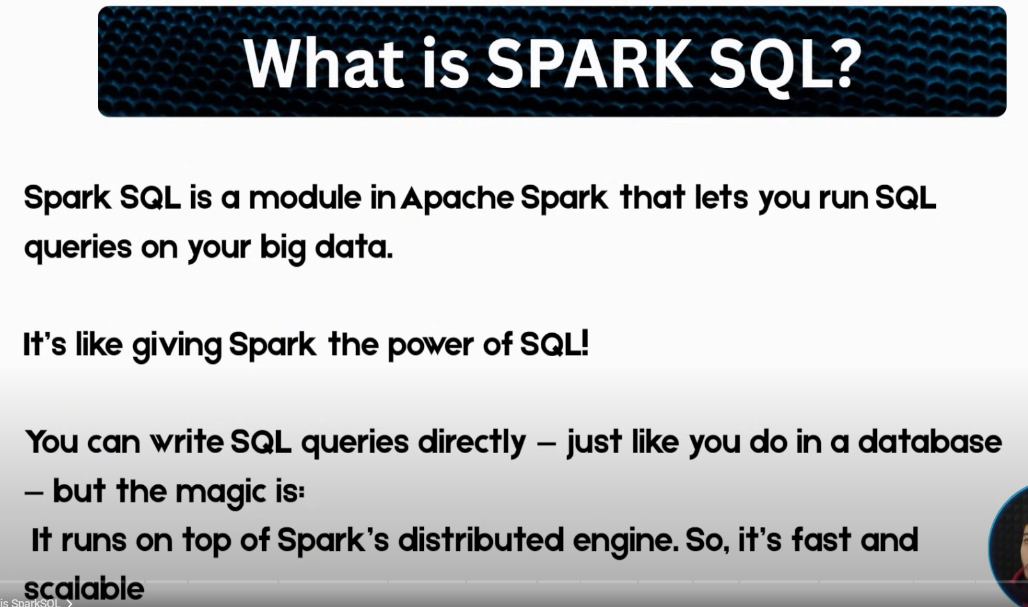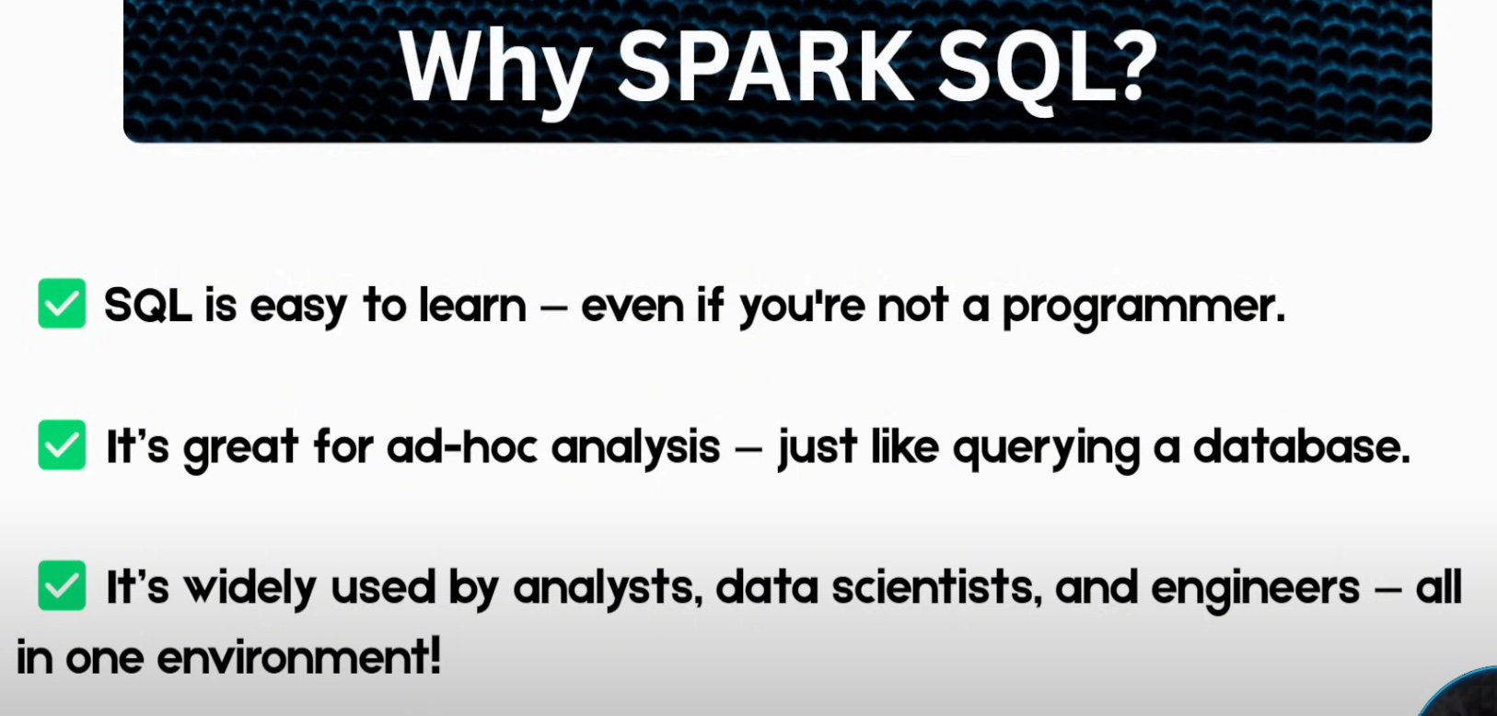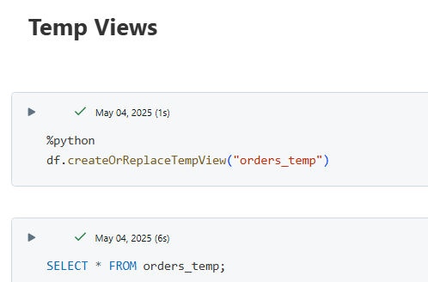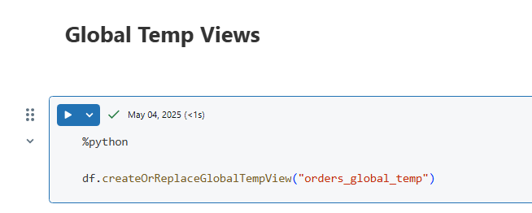  
Temp views are only available for the Notebook session, Global views remain till the cluster is not killed, available in all the sessions of the same cluster. 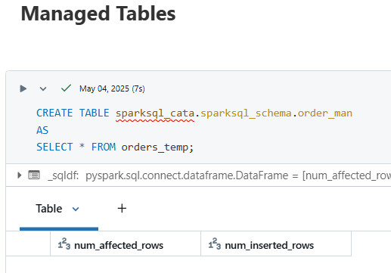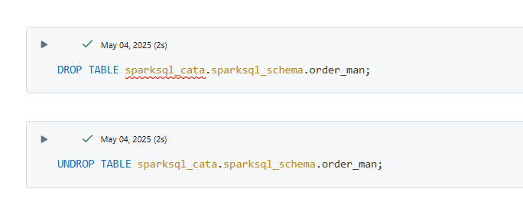  
UNDROP is a unique functionality in Managed Tables, even after deletion data gets retained for some time  
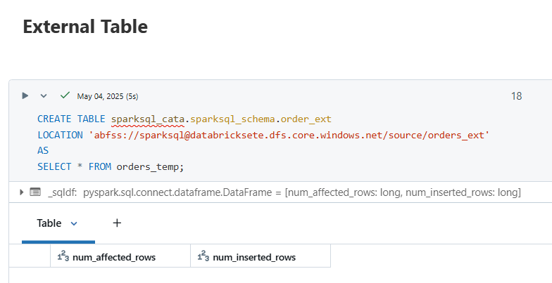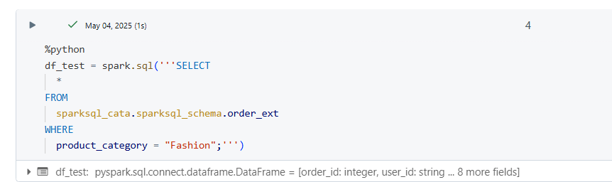  
  
SQL Warehouse 🡪 compute built for SQL workloads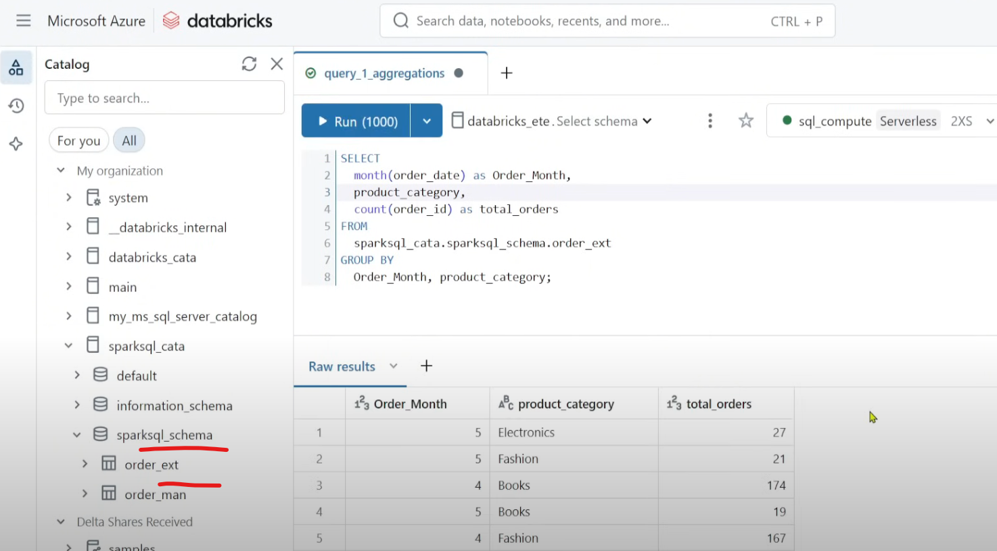  
Sequence of execution : from 🡪 where 🡪 groupby 🡪 select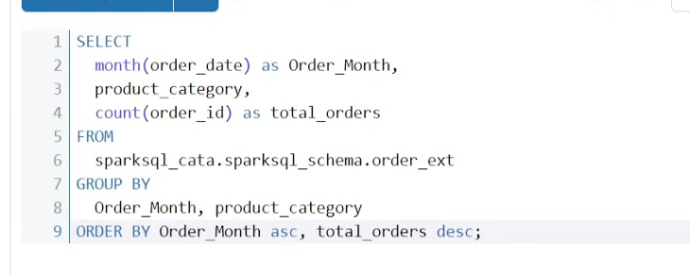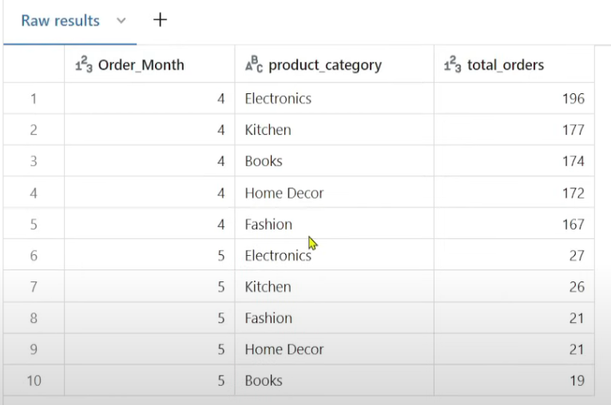

Subquery  
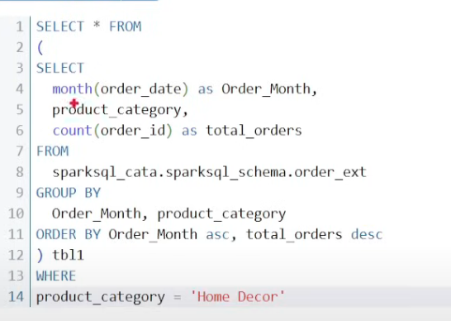

Conditional statements  
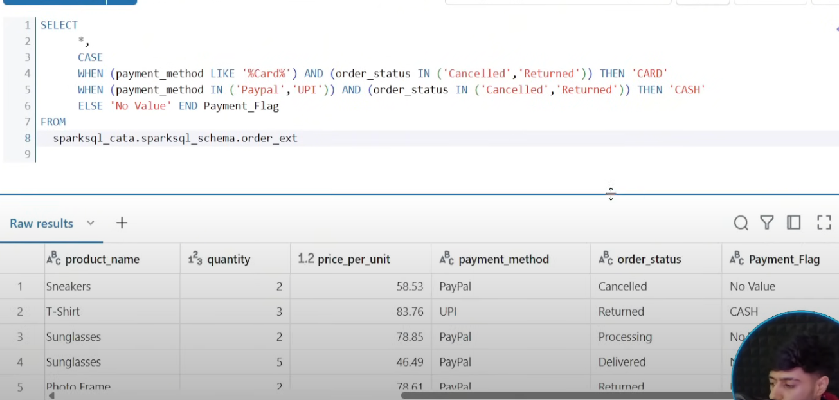

Subqueries are alternatives to CTE  
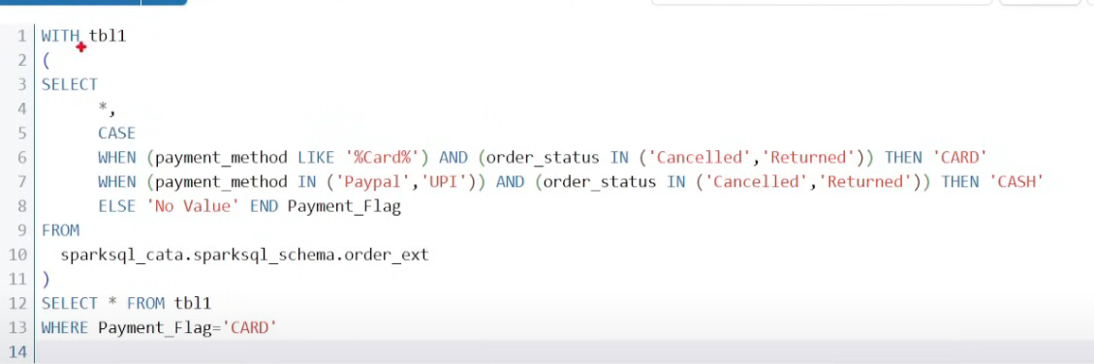

Hierarchial CTEs  
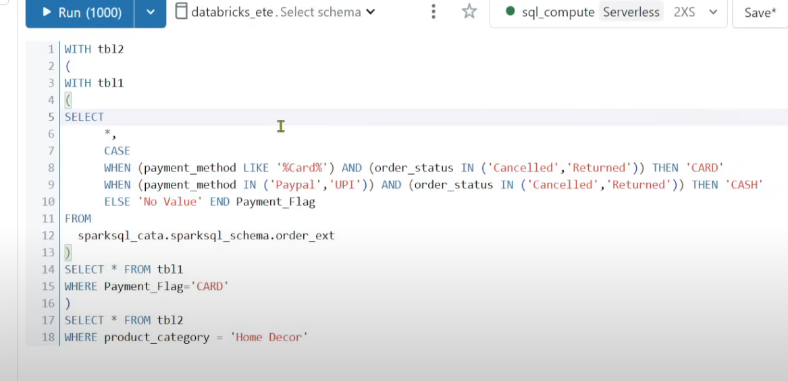

Window Functions  
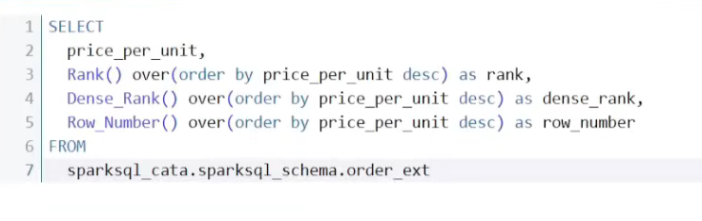  
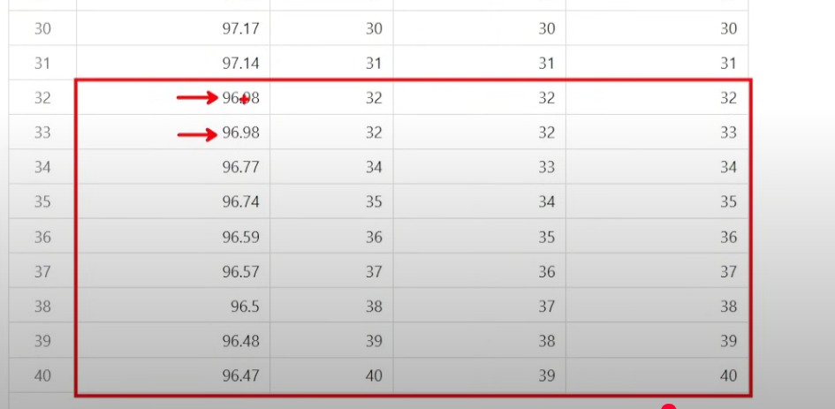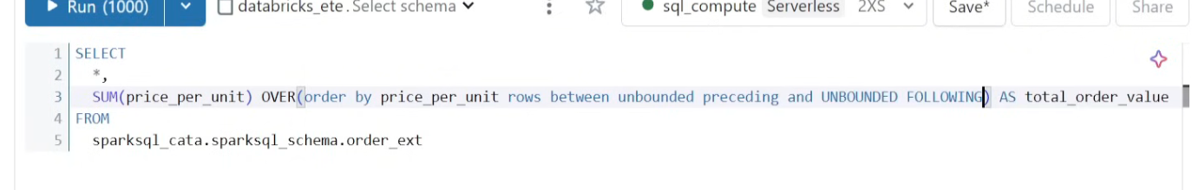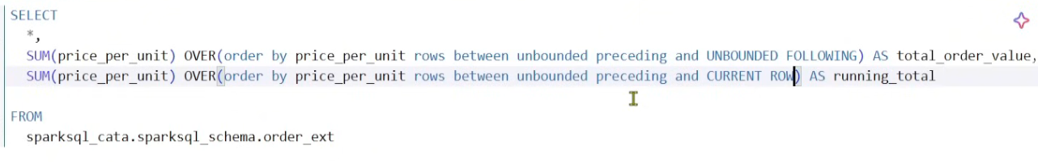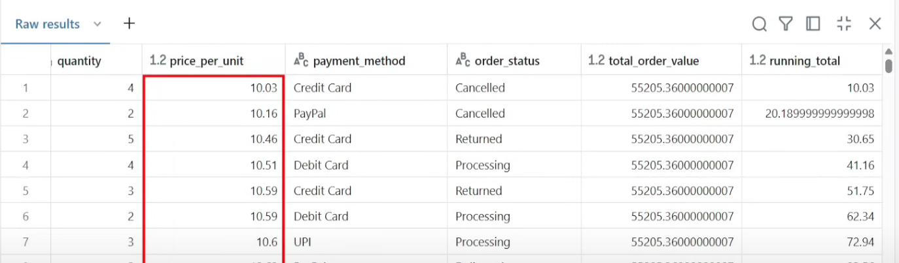  
  
  
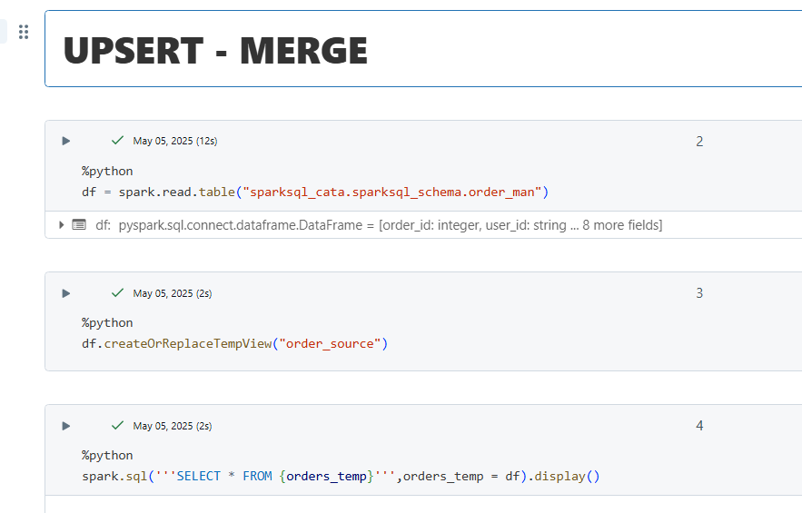  
The last 2 commands are equivalent  
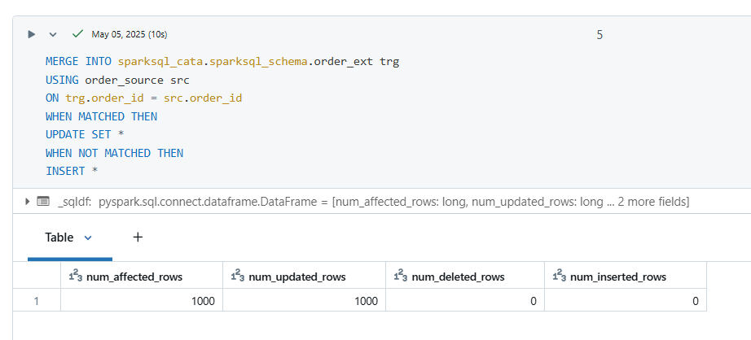  
  
**FUNCTIONS**  
2 types 🡪 1) User Defined Scalar Function 2)User Defined Table Function  
Register Functions in UC  
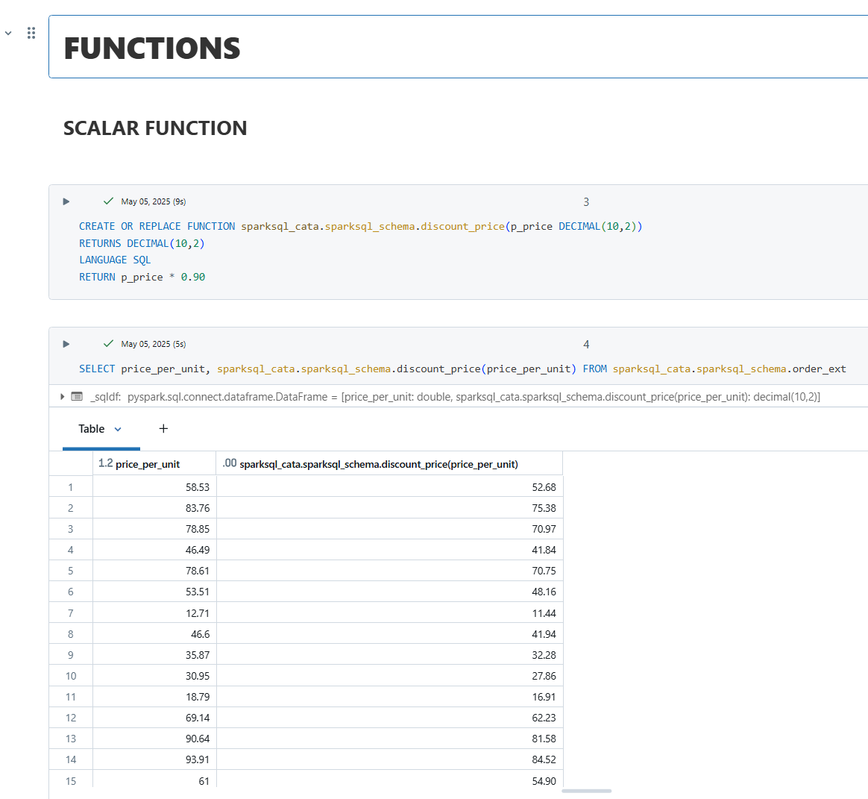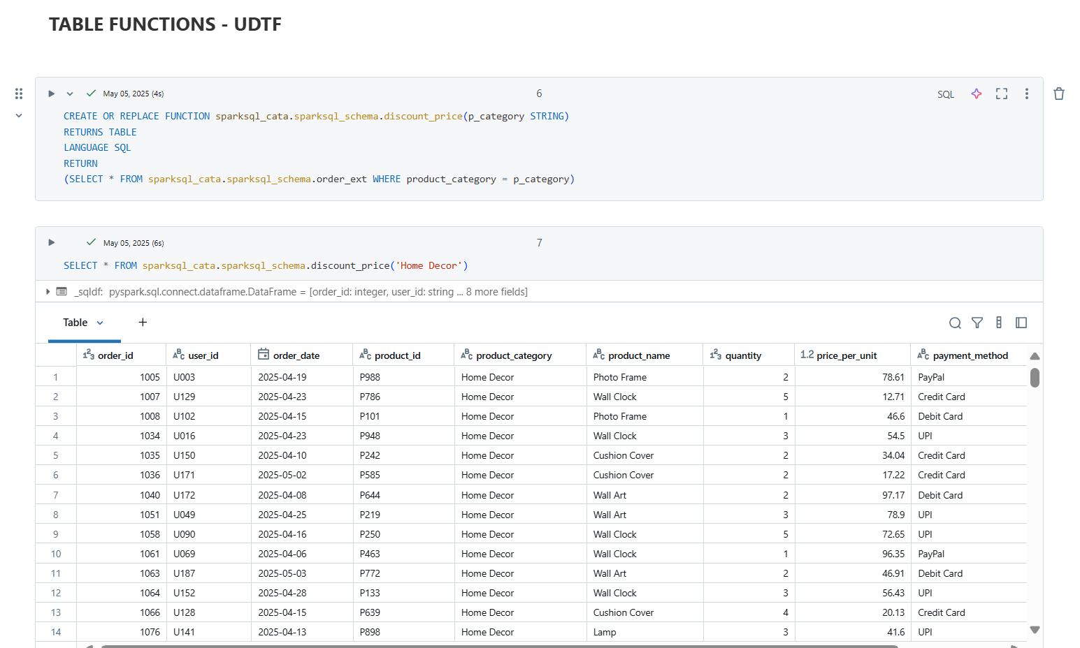  
  
  
**Dynamic Data Masking**

Prerequisite: need amin rights  
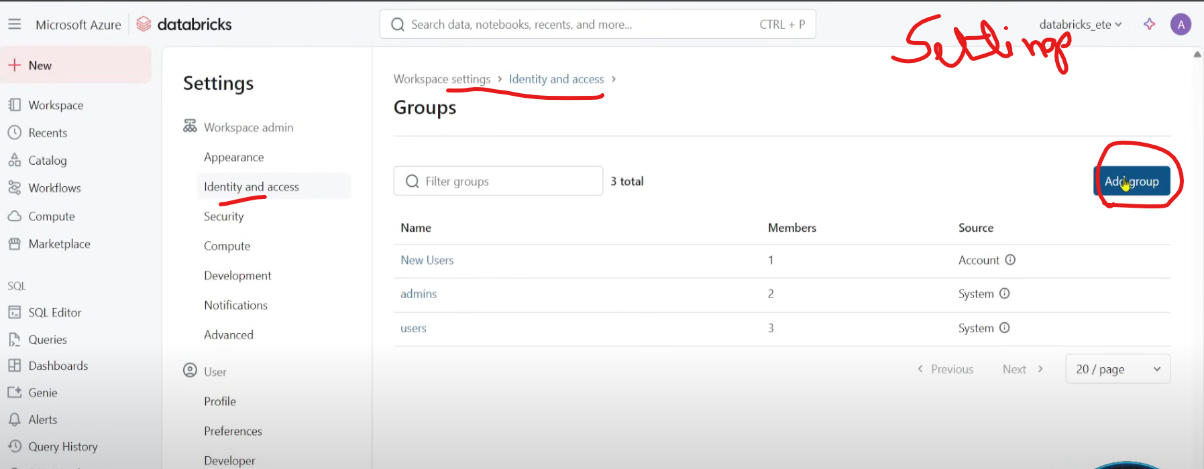  
Add yourself as an admin  
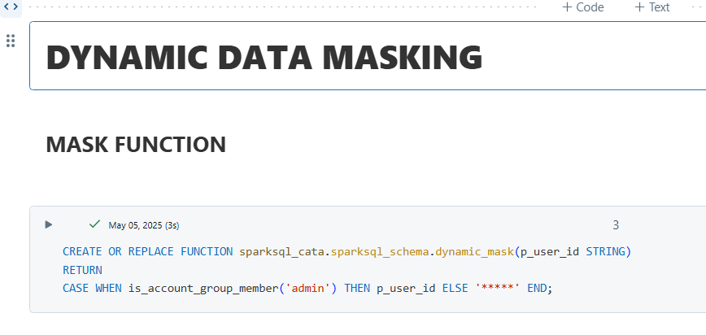  
Masking PII (Personal identifiable information) 🡪 used_id  
is_account_group_member() is an inbuilt function 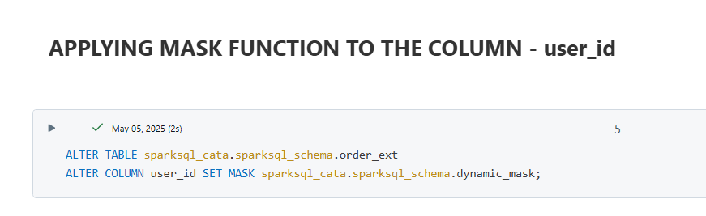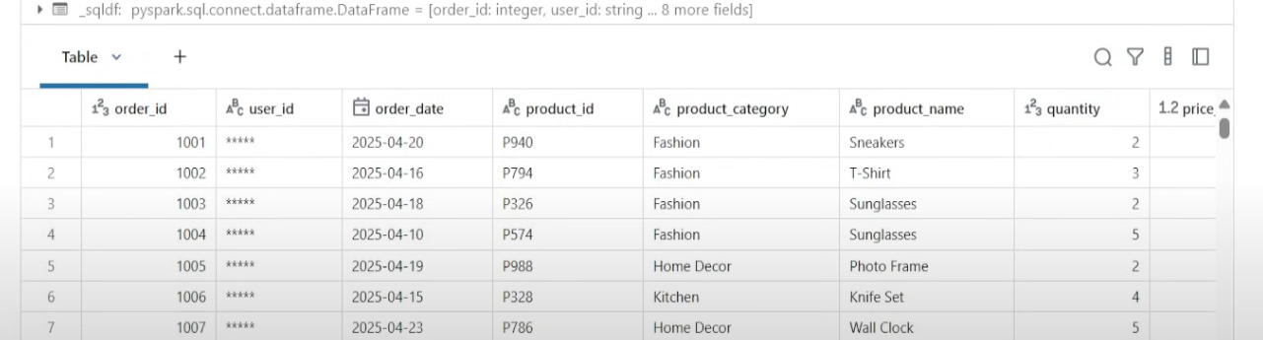

**Row Level Security** 🡪 restricting access to the users/what users should have access to what data  
(Normally applied in PowerBI but can be used in ADB)

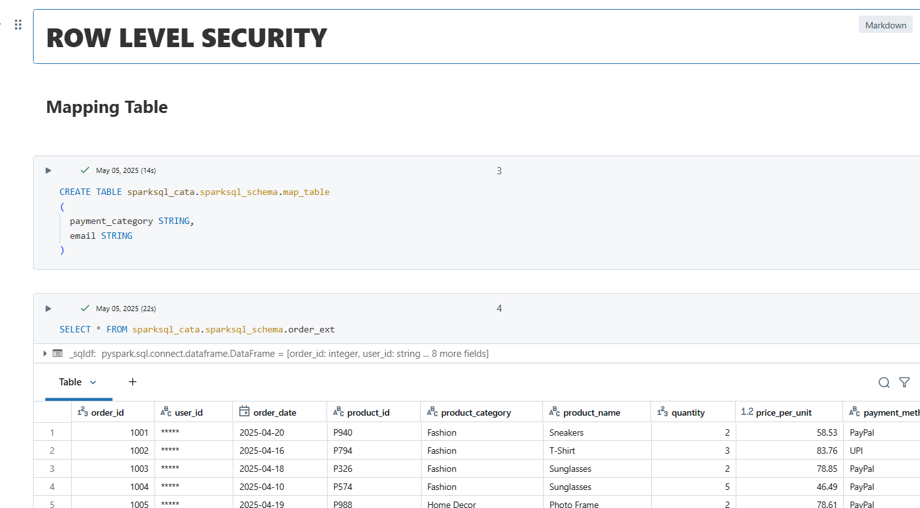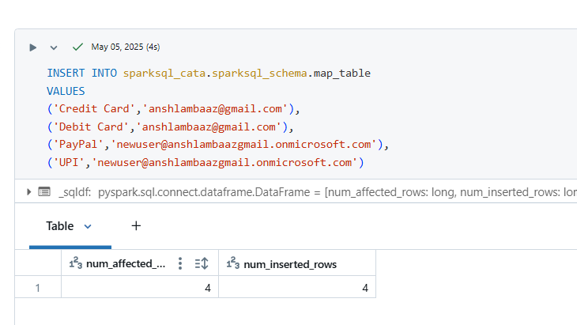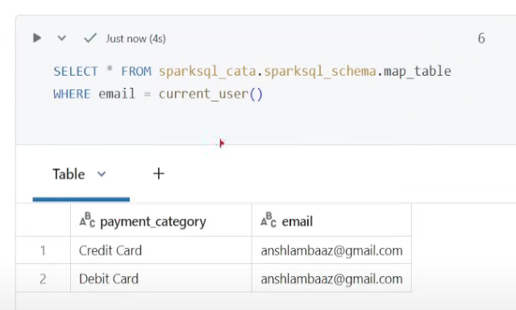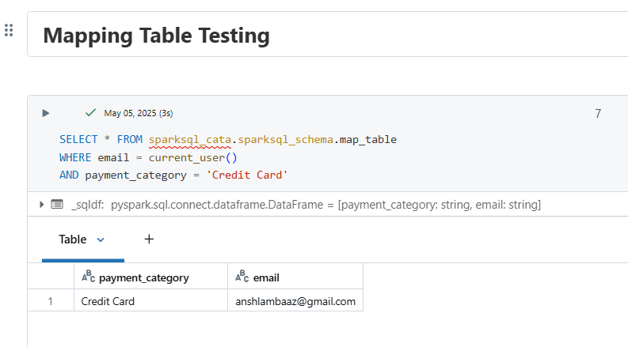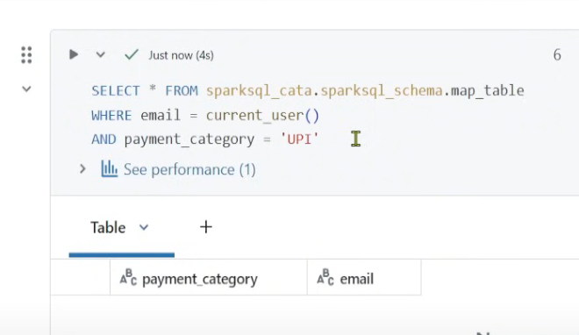  
No data cause UPI data should be visible to the other user  
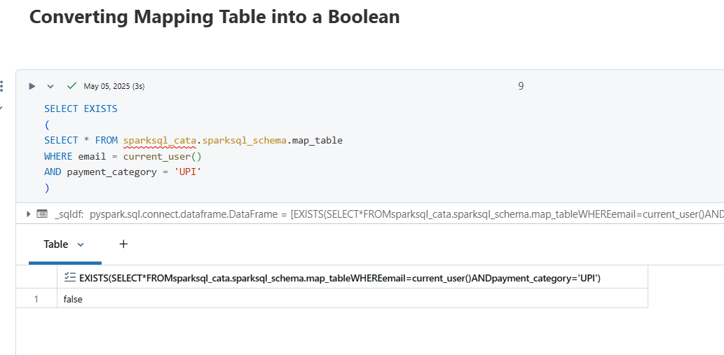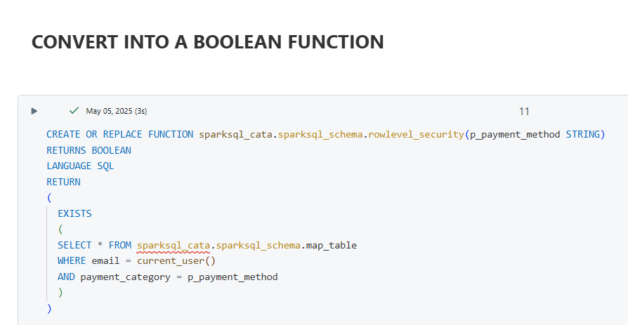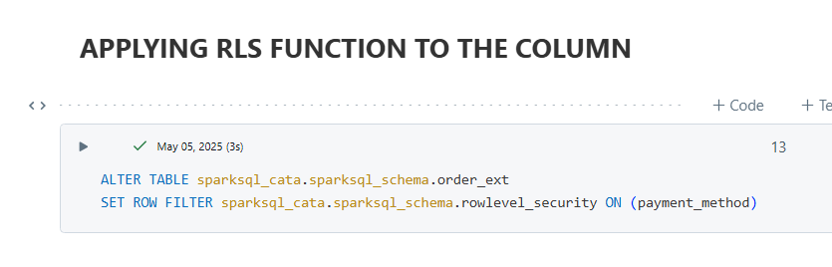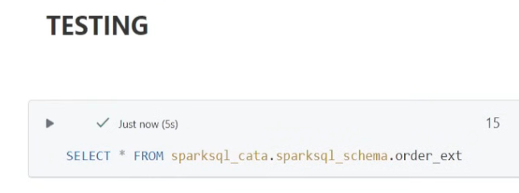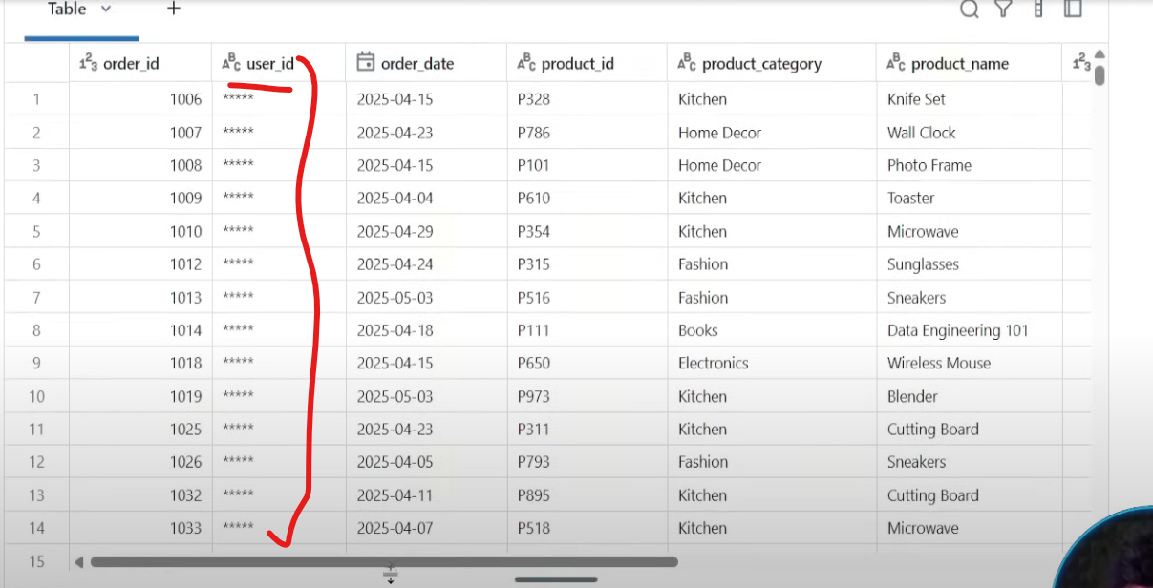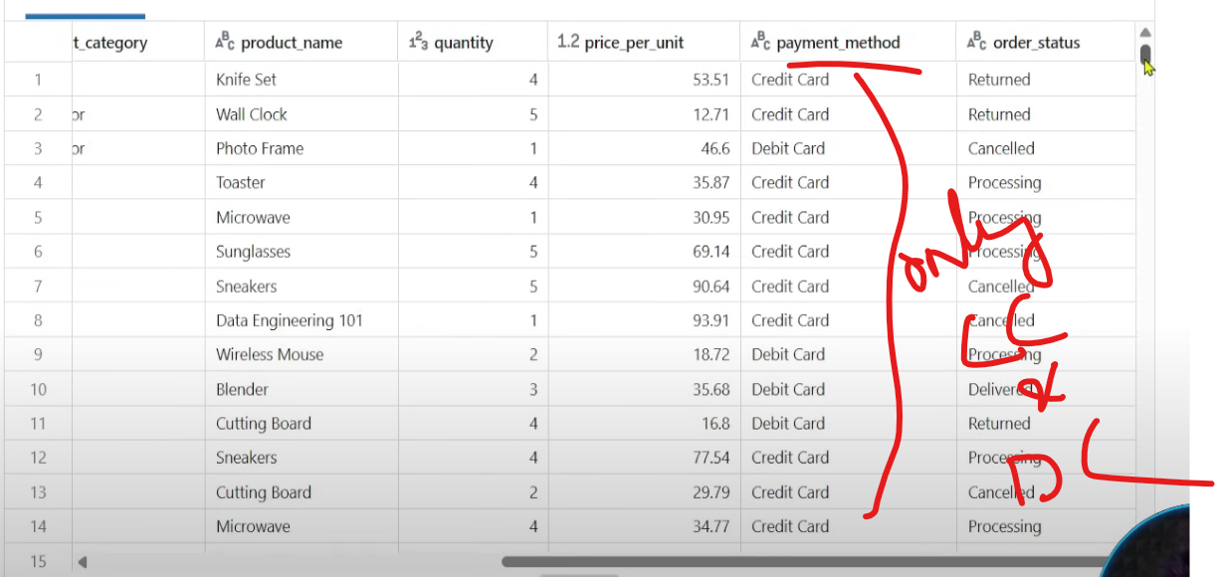  
So whats happening bts : when we are querying the table, we have applied row filter on payment_method column, simply pass all the values to the rowlevel_security function, this function will take all the values of payment_method & check the current user and privilege of that user.

DML/DDL on Delta Tables  
 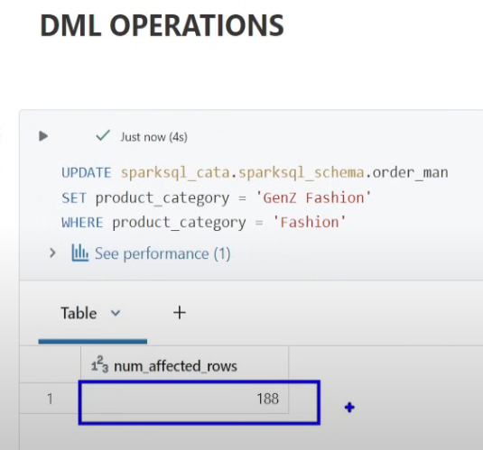 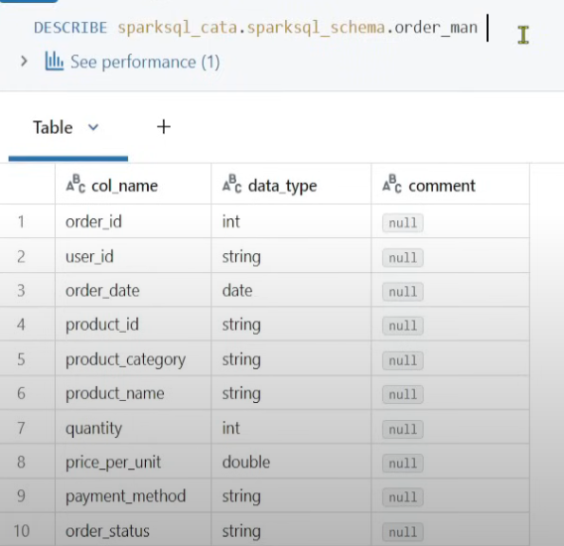 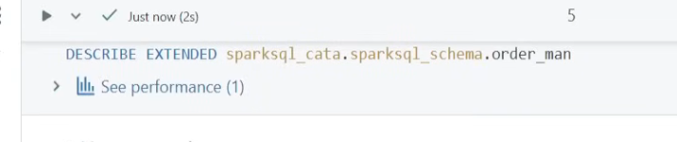 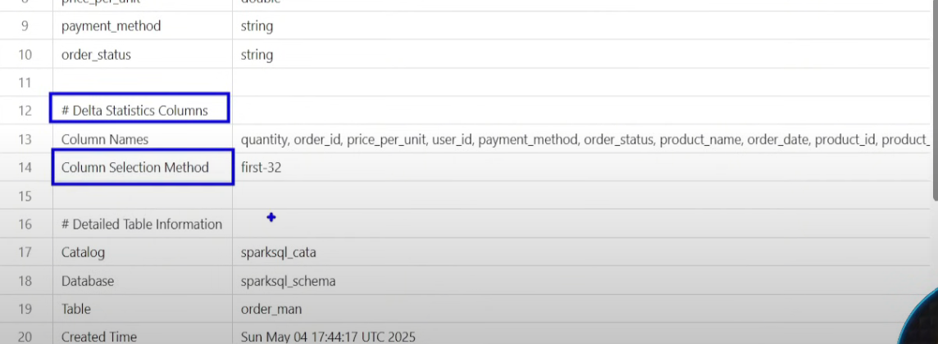  
Delta Tables calculate the statistics of first 32 columns  
  
To see performance  
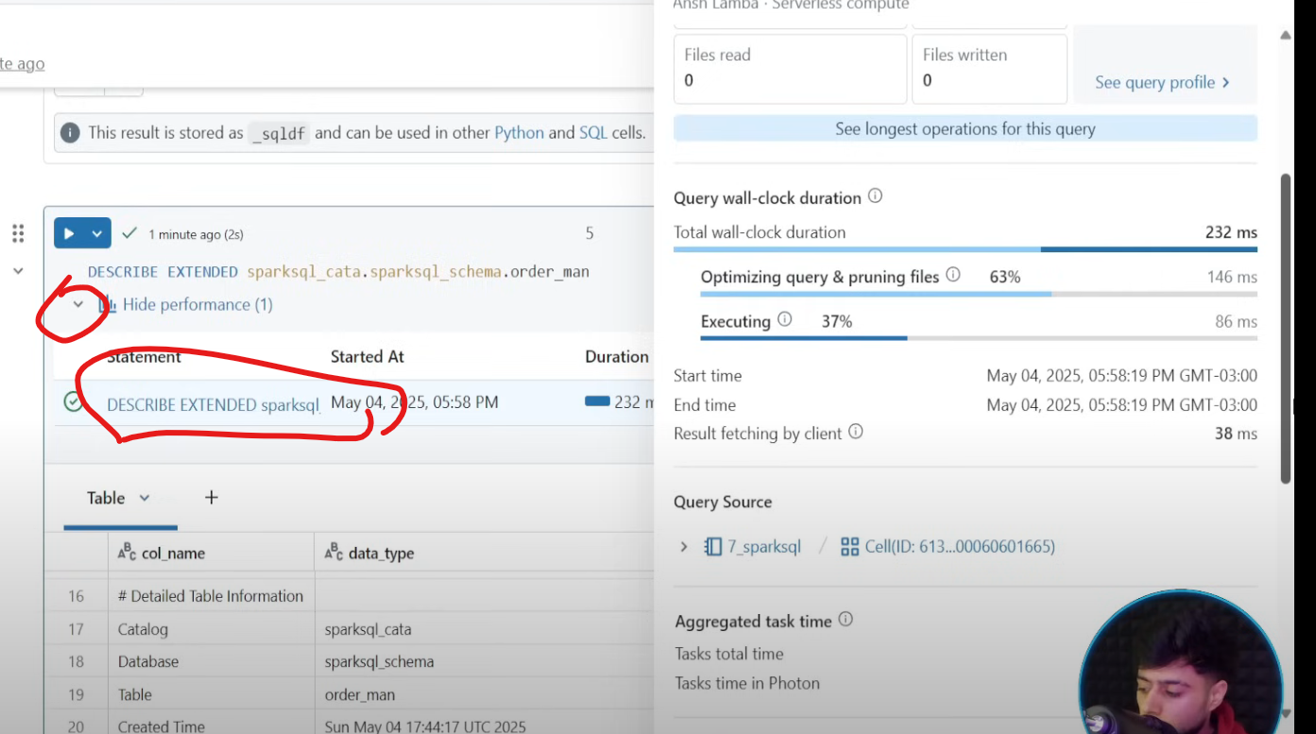  
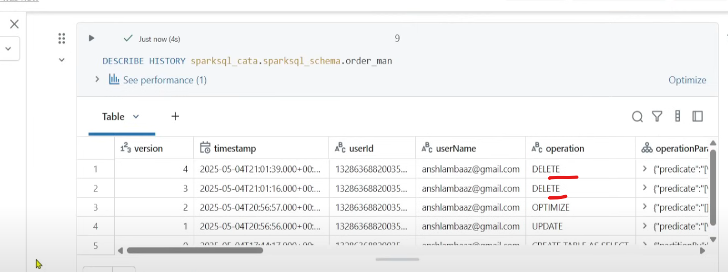 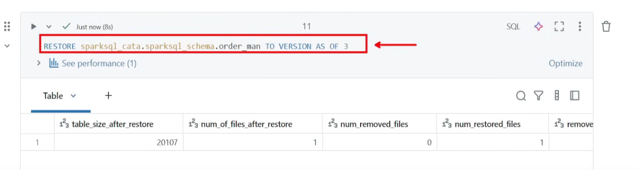  
  
Different approach  
